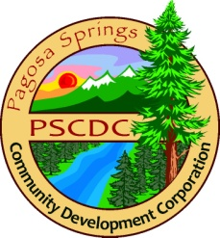

Pagosa Springs Community Development Corporation
Work Session Agenda
Wednesday, March 28, 2018
11:00 a.m., 1st Southwest Bank

- Review of February 27 Work Session meeting notes

- Financials

- Chamber Update
  - Activity
  - Business Inquiries
  - Grant applications

- Broadband
  - RFP coordinator discussion: Scope of services - Jason
  - Request funding from Special Projects Working Group – Criteria report from Sherry/MJ

- Data Analytics
  - What questions do we want to ask?
  - What type of data are we looking for?

- Old Business
  - CDC Retreat – Thursday, April 12, 11 a.m. – 2 p.m., 1st Southwest Bank
  - CDC Annual Meeting - May 9, Springs Resort & Spa, 5:30-8:30 p.m.
  - Elections & By Laws

